**Project Design Phase-I**

**Problem Solution Fit**

|  |  |
| --- | --- |
| Date | 01 October 2022 |
| Team ID | PNT2022TMID47454 |
| Project Name | Smart Farmer IoT Enabled Smart Farming Application |

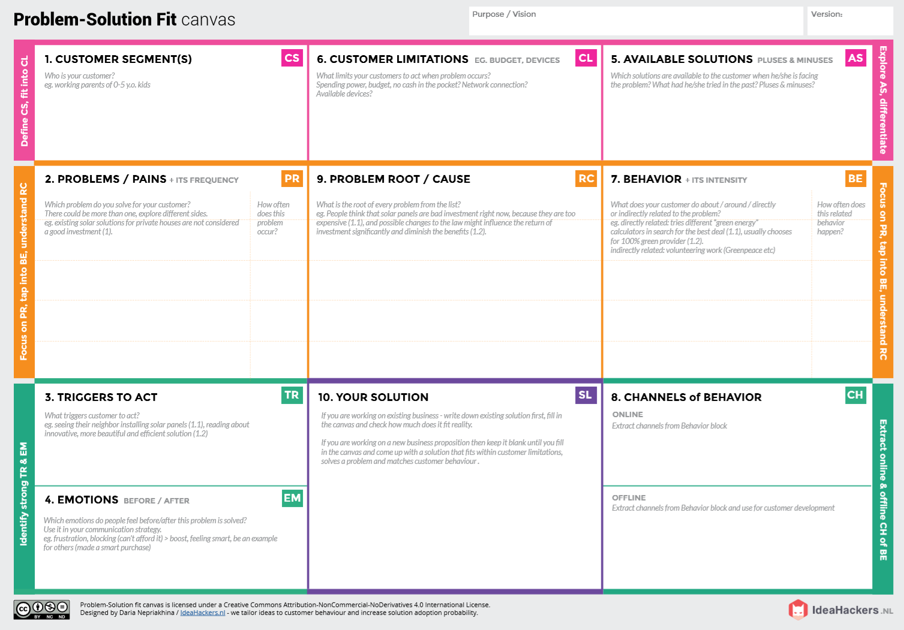

**OFFLINE:**The control action is taken by the farmers to monitor the crop field.

**Before:** **Farmers are affected by less productivity due to decrease in Temperature, PH level, humidity and light intensity.**

**After:** **It will make easier to farmer to make more yield in the field**.

**ONLINE**:  
The data is send through application for the farmer to know about the crop field.

The “Smart Farmer IoT Enabled Smart Farming Application” that records all the parameters and send through the web or mobile application.  
 The instant alert message is also sent to the farmers that will make more profit and less work.

Farming can help reduce poverty, raise incomes and improve food security for 80% of the world's poor, who live in rural areas.

Lack of knowledge about monitoring the crop field on their web or mobile.

Farmer may use traditional method to yield in the field in smaller percentage.

Farmers used to complaint about climate Change, Soil erosion and Bio-diversity loss.

• To monitor different parameter such as soil Moisture, Temperature and humidity.

• Using Web or mobile application farmers easily monitor the crop field.

• If Temperature, PH level, humidity and light intensity makes the serious cause for the environment.

• Farmers affected by less productivity which will affect them in their profit.

• If the farmer is far from the crop field, it is difficult for farmer to monitor and control.

• Farmers cannot know if the application does not work properly.

Farmers can monitor all the sensor parameters by using a web or mobile application even if the farmer is not near his field.